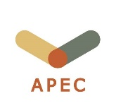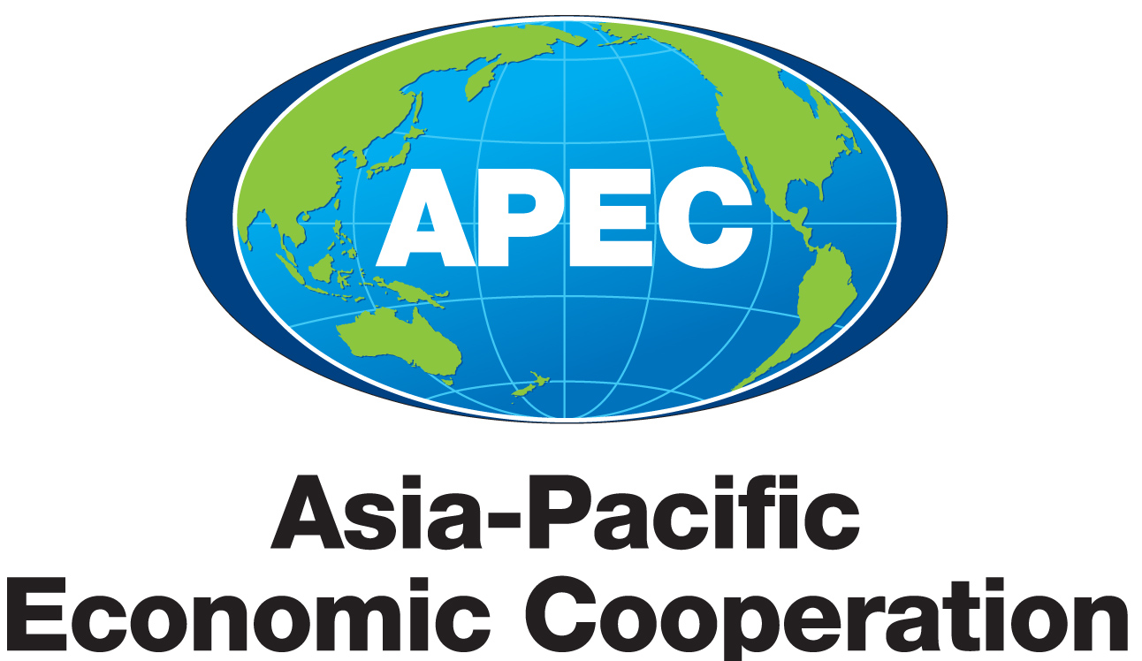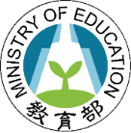

**TVET Workshop on**

**Regional Industry-Academia Collaboration for Talent Development and Inclusive Growth: Skill Training, Internship, Jobs and Women**

7 May, 2021, Taipei

**Open Invitation**

Dear HRDWG members,

It is our great pleasure to announce that the “TVET Workshop on Regional Industry-Academia Collaboration for Talent Development and Inclusive Growth: Skill Training, Internship, Jobs and Women” will be held on 7 May, 2021 in Taipei. We truly appreciate your support of Chinese Taipei’s proposal to organize this hybrid event which will strategize seamless network of cross-regional and interdisciplinary collaboration through industry-driven vocational education and training programs that cultivate talents to meet industry demands across economies and to encourage female participation in non-traditional sector.

The tentative program for the workshop this year will consist of a Keynote Speech, two invited talks in the morning and two parallel sessions in the afternoon. Topics discussed are related to Digital Healthcare Talent Demand and Engineering Education Cultivation, we welcome those who are interested and trained in these fields to join us.

It will be our honor if you would join us for the workshop. Online registration is at: <https://forms.gle/uYrYobxXNXco8APt7>.

Responding to our invitation by 9 April 2021 will be appreciated, in order to help us make suitable arrangements. If you have any inquiries regarding the workshop and/or the program, please contact Dr. Yun-Hua Yang or Ms. Zoe Chang ([yhyang@ntut.edu.tw](mailto:yhyang@ntut.edu.tw), [acexch@ntut.edu.tw](mailto:acexch@ntut.edu.tw)).

We look forward to seeing you online.

Warm regards,

Dr. Pan Wen-Chung

Minister of Education

Chinese Taipei